JA NUAR Y 2018

T HE M A GA ZINE O F THE A MER ICA N S O CIET Y O F CIV IL E NGINEER S

Civil Engineering
N E W S

E N V I O N M E N TA L E N G I N E E R I N G

Construction Begins
On Lagoon Restoration Project near San Diego
ONSTRUCTION recently began on a long-planned effort to r­ store the San Elijo Lagoon, one
C
of several such bodies of water along the coast of San Diego County, California, that · has experienced deleterious effects because of past development, Intended to improve tidal flows, enhance water quality, and create new wetland habitat within the nearly 1,000-acre lagoon, the
$120-million restoration project is one
component of the larger effort known
\
as the North Coast Corridor (NCC)
program. To be conducted during the next three decades, the NCC pro­ gram will include significant up­ grades to Interstate 5, improvements to the regional rail system, enhance­ ments to bike and pedestrian facili­ ties, and protection and restoration of environmental resources .
Located on the California coast between the cities of Encinitas and Solana Beach, the San Elijo Lagoon has undergone significant physical changes as a result of bridge con­ struction and other human influenc- es. Before the lagoon was subjected to human intervention, its inlet is
thought to have remained open most of the time, facilitating tidal flows within the water body. However, the construc­ tion of a rail bridge and berm across the
' lagoon in 1881, followed by the con­ struction of the Pacific Coast Highway a decade later, "locked" the inlet in its current location and helped lead to its closure, says Doug Gibson, the exec­ utive director and principal scientist for the San Elijo Lagoon Conservancy (SELC), ofEncinitas.
Subsequent decades saw the devel­ opment of two municipal wastewater treatment facilities on the shore of the lagoon, while a third was located up­ stream on a waterway that drains into
the lagoon. With the inlet closed most of the time, the discharges from the
. treatment facilities led to the deposition of nutrient-laden sediment within the lagoon, as did increased runoff entering the lagoon from upstream development. Upon its completion in the mid-1960s, I-5 bisected the lagoon, amounting to the "nail in the coffin" in terms ofits wa­ ter circulation and creating a "cascade of other effects," Gibson says.
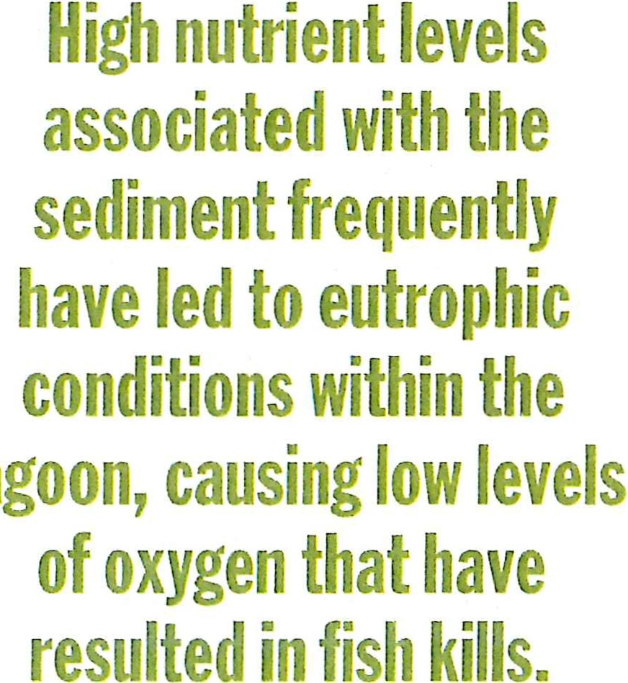Most conspicuously, the earthen berm built for the highway constrict­ ed water flows to an approximately 120 ft wide channel. The narrow open­ ing caused water from upstream to back up in the lagoon, exacerbating the prob­ lem of sediment deposition. In turn, high nutrient levels associated with the sediment frequently have led to eutro­ phic conditions within the lagoon, caus­ ing low levels of oxygen that have result­ ed in fish kills. California has designated the lagoon as impaired under Section

303(d) of the Clean Water Act for its high levels of sediment, nutrients, and bacteria.
The closure of the inlet led to the im­ poundment of freshwater within San Elijo. Lagoon for long periods of time, resulting in significant changes in habi­ tat types. In general, the lagoon trans­ formed from a "highly channelized and vegetated system" to one that, in places, largely lacked vegetation and "started to act like mudflats," Gibson says. In oth­ er locations, areas that had been popu­ lated by saltwater vegetation have been colonized by freshwater species. Despite these changes, the lagoon remains a crit­ ical habitat for avariety ofplants and an-
imals, including two endangered bird species-the Ridgway's Rail (Ralltts ob­ soletits levip) and the Belding's Savannah Sparrow (Passerctt!tts sandwichensis beld­ ingi). Both species inhabit coastal salt marsh, a type of habitat that has been greatly diminished by development.
In 2001, the SELC began excavating the inlet annually to return tidal flushing to the lagoon system. However, the exist­ ing sediments that contain high levels of nutrients continue to impair the health of the lagoon, as does the constriction of water flows caused by the I-5 bridge. For itspart, the NCC program aims to address both issues by means of improvements to I-5 and by a separate effort to remove the sediment and reconfigure much ofthe la­ goon to create the conditions necessary to promote certain habitats.
The ongoing $480-million NCC project to improve I-5 from Solana Beach to Carlsbad includes the addition of a new high-occupancy vehicle (HOV) lane in each direction as well as the construction of new sound walls.
The addition of the HOV lanes re­ quires the replacement of the exist­ ing bridge that spans the San Elijo Lagoon. Besides being wider to ac­ commodate the HOV lanes, the new bridge will be longer to improve la­ goon health, says Arturo Jacobo, P.E., the project manager for the Califor­ nia Department of Transportation, which is overseeing the project .Mod­ eling of the lagoon's hydrology in­ dicated that doubling the existing
. channel width at the location of the I-5 bridge would restore tidal flush- ing to the large section of the la­ goon east of the interstate, Jacobo says. Whereas the existing four-span bridge has a length ofapproximately 341 ft, the new three-span structure will be approx­ imately 559 ft long. "That is sufficient to restore.the tidal flushing to the east side
of the lagoon," he says.
Designed by T.Y Lin International Group, the new bridge is being con­ structed by a joint venture compris­ ing the Flatiron Construction Corp., of Broomfield, Colorado; the interna­ tional construction company Skanska; and Stacy and Witbeck, of Alameda, California. Known as FSSW, the joint venture was hired to deliver the first phase of the NCC program, including

[ 2 8 ] C i v i l E n g i n e e r i n g J A N U A R Y 2 0 1 a

-+-+ Railroad
IMPACT FOOTPRINTS (other projects)
c:J 1-5 expansion
[SSJ Railroad expansion (preliminary)
c::J Project boundary
HABITAT TYPES
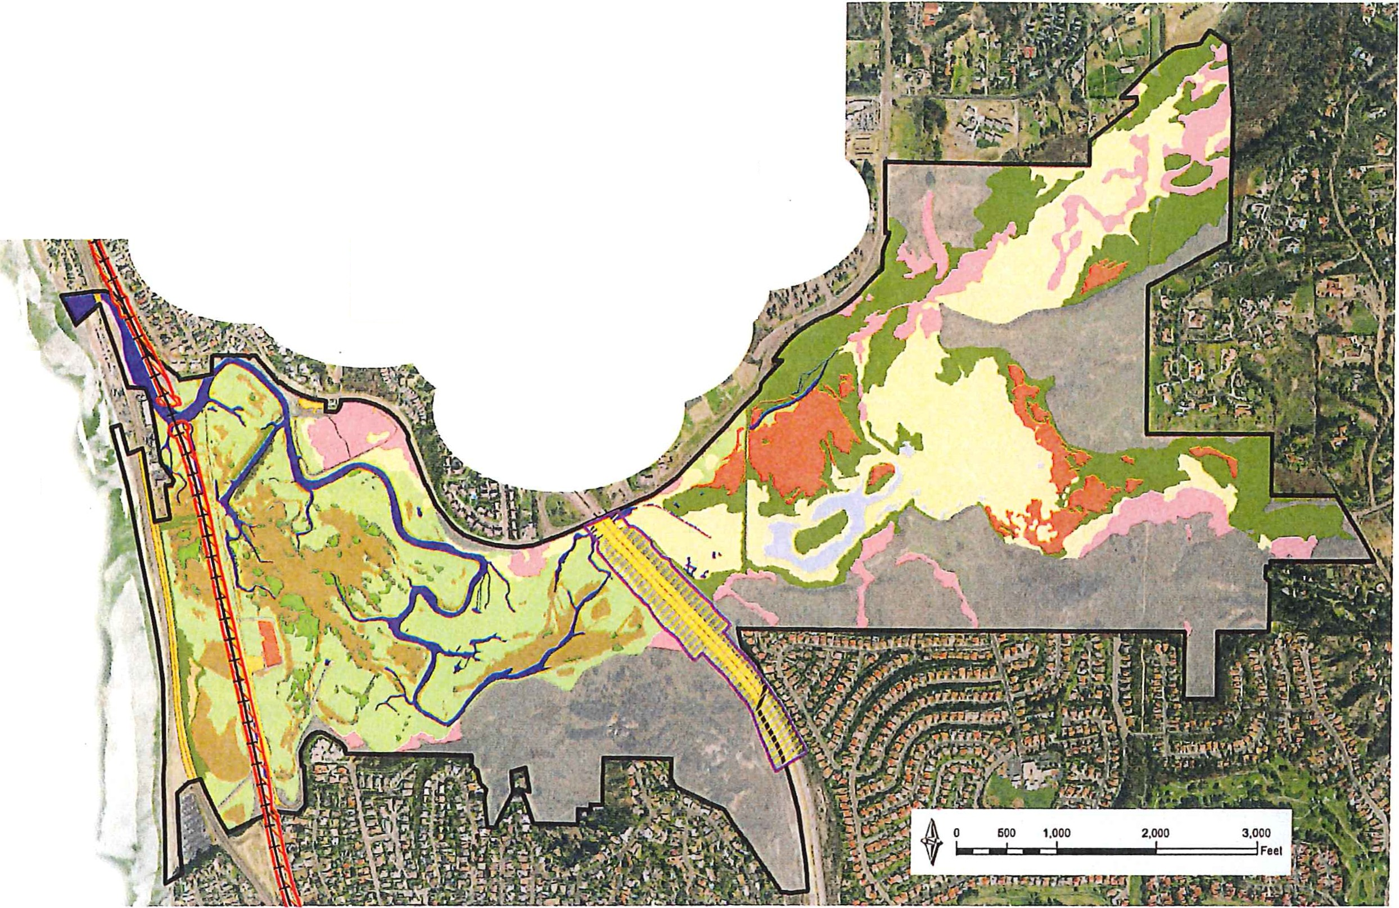Low salt marsh SELG GODE
D Berm roads
Coastal strand
- Channel
- Mudflat
Middle salt marsh High salt marsh

Salt panne Riparian Open water/
freshwater marsh
Freshwater/ Brackish marsh
Upland

SAN ELIJO LAGOON, EXISTING HABITATS

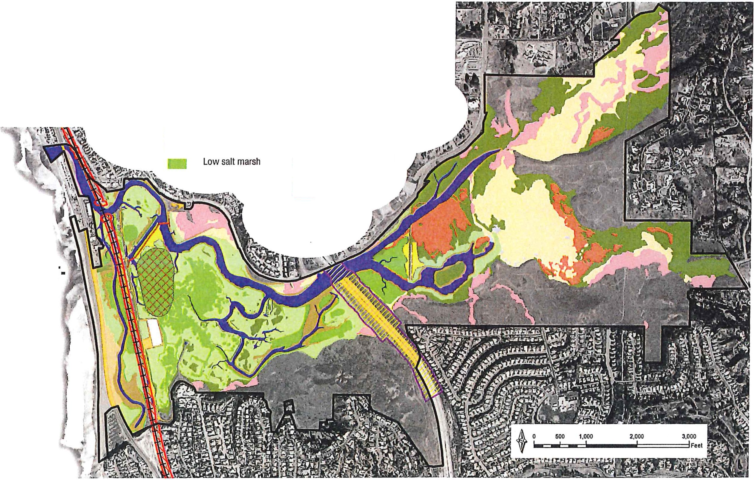Cl
of-+
CJ
--
Railroad
Project boundary Targeted low marsh Pedestrian bridges
Pedestrian trail
Transitional areas
HABITAT TYPES
CJ
-
-
-
D
Avian nesting area
Berm/roads Coastal strand Eelgrass
Tidal channel and basin
Mudflat
Middle salt marsh
High salt marsh Salt panne Riparian
Open water/freshwater marsh Freshwater/brackish marsh Upland
C3 Railroad expansion (preliminary)
Q 1-5 expansion
SAN ELIJO
LAGOON, POST· RESTORATION HABITATS
,":'
t.l 2

the improvements to I-5, as well as the restoration of the San Elijo Lagoon, by means of the construction manager/ general contractor method. I this way,
FSSW was able to join the effort dur­

I-5 bridge in late 2016 and is expected to conclude in early 2021.
Also as part of the NCC program, FSSW is replacing an existing single­ track timber rail bridge located in the

track on the coastal rail corridor in San Diego County, the new rail bridge will have fewer support columns than the ex­ isting structure, further helping to in­ crease tidal flows within the lagoon.

: ing the design phase and offer input on
: how best to conduct the project, Jacobo says. Construction began on the new
San Elijo Lagoon with a new double­ track concrete bridge. Conducted as part of efforts to add a second mainline rail
As for the restoration of the lagoon itself, the notice to proceed was issued to FSSW in November 2017, Gibson

J A N U A R Y 2 0 1 0 C i v i l E n g i n e e r i n g [2 9 ]

Civil Engineering
N E W S

says. To be completed by early 2021, the restoration will take a two-pronged approach that entails deepening and widening channels to improve water circulation in addition to contouring various areas to increase certain habi­ tat types. To improve water quality, the nutrient-laden sediment will be exca­ vated and placed in a 40 ft deep pit, which will be created by the removal of about 580,000 cu yd of sand to seques­ ter the fill material. The filled pit then will be capped with sand and topped with crushed shell to facilitate its use as an avian nesting area.
Accurately determining the antici­ pated consolidation rate of the dredged materials to be placed in the pit proved to be a "very challenging design issue," says Chris Webb, a supervisory coastal scientist for the global infrastructure advisory firm Moffatt & Nichol, which has served as the design engineer and prime consultant on the project for the SELC. "We're trying to achieve a very specific final elevation," Webb says. If the materials consolidate too much, the area occupied by the pit will become mudflat or subtidal habitat, rather than the low salt marsh that is expected to result over time. Because low salt marsh is the habitat of the Ridgway's Rail, "we want to have as much out there as possible," Webb says.
If the materials in the pit were to consolidate too much, the extreme­ ly fragile nature of mu2h of the la­ goon would greatly complicate any ef­ forts to return to the site in the future to attempt to rectify the problem. "It would be challenging to fix," Webb notes, particularly because of the pres­ ence of sensitive habitats and endan­ gered species. Infact, these constraints represent one of the other main design challenges that had to be overcome on the current project. Restoring degrad­ ed natural areas while in close proxim­ ity to fragile ecosystems and rare spe­ cies requires "very clear demarcation" of which areas are protected and which can be disturbed during construction, Webb says. -JAY LANDERS

